Add a Nurse

Functionality: This dialogue allows the user to add a Nurse to the Main Org. It allows the user to capture all information necessary for billing, contacting and tracking. The Add-a-Nurse Doctor dialogue, in Physia, handles the majority of this. First a review of fields will be discussed and then the action codes will be discussed.

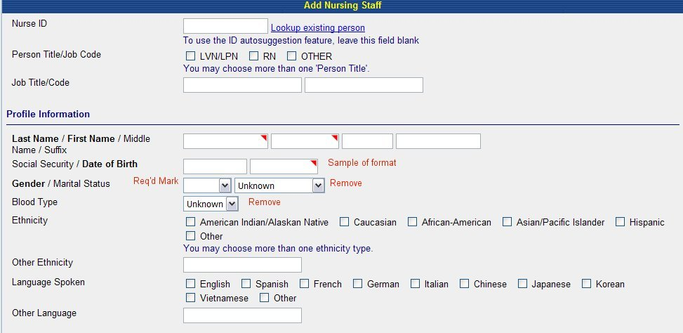
Fig 1a

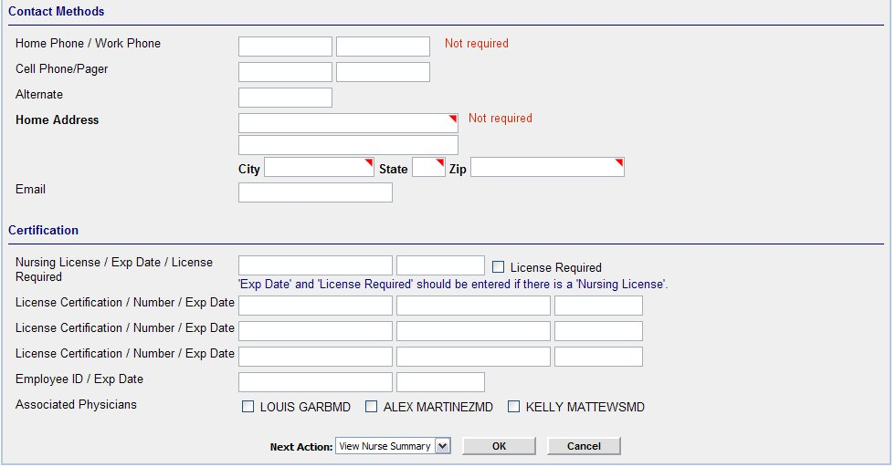
Fig 1b

Add:
- Look up for existing person.
- Facility ID with a Look up or list (see Example below for Ethnicity) this list should include all Orgs added in Associated Provider and Departments.

Remove:
- Marital Status
- Blood Type

Edit:
- Home phone should not be required.
- Choices for ethnicity and Language Spoken should be the same for all Add dialogues. (See Medspective below)

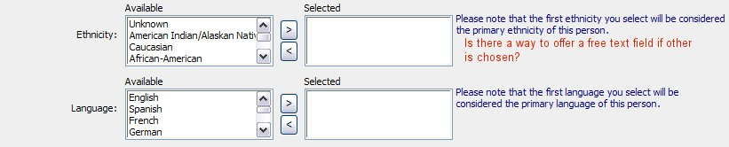
Fig 1c

- Required fields: Last Name, First Name, DOB ( address may be required in the future if the application will handle Human Resource functions in the future.)

Action Codes
Look up an existing person: This lookup, whether an icon (magnifying glass or the words are a hyperlink) should take user to a search dialogue which allows the user to search for a person—see below. ***Note the method chosen for lookup should stay consistent throughout the application. **

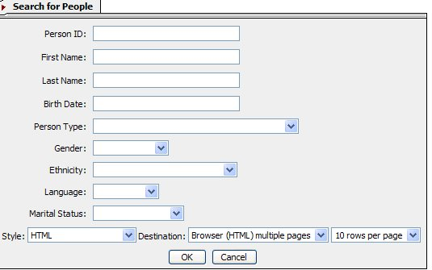

Fig 2a
This is a good search engine, because it is a search engine for all persons.

Add

- If birth date has to be in a certain format, then to the left of the Birth date box, should be a message stating the format (mmddyyyy). **Note: Anywhere in the application, where information should be entered in a certain format, there should be a small example of it near the field.

Once the user clicks OK, the system should pull up the results. See below. ***Note: Search results include all types of persons.

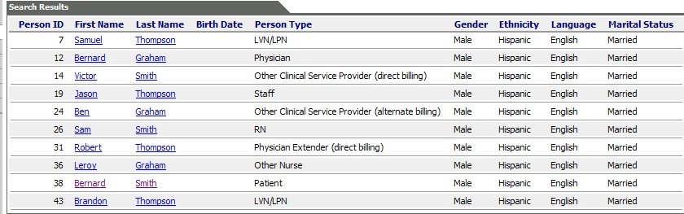Fig 2b

Edit

- The hyperlink to the Person Summary should be on the person ID.
- Switch Last Name column with First Name Column
- Sort in alphabetical order by Last Name.
- If a person is in several Person Types-either all types should be listed under the Person Type column or the person should have a row for each person type. (These will appear beneath each other since the persons will be listed alphabetically.)

Function

a) If a person is found in Org but not as a Nurse Person type, then the user should be able to click the Person ID (the hyperlink) and an additional dialogue should come up:
***If Person ID hyperlinks to patient summary (as requested above) - can it also function to bring up the Person ID (the hyperlink) and an additional dialogue should come up:
***If Person ID hyperlinks to patient summary (as requested above) - can it also function to bring up the above dialogue? If not then can the name be made a hyperlink to summary page and Person ID made to be the link to above dialogue? *****

Do you want to add Nurse Person Type to [Person_id]? →Yes→Dialogue for Add-a-Nurse comes up with as much information as possible auto filled→User enters any additional information→User chooses Next Action→User clicks [Ok]→Application performs Next Action.
**See further down for descriptions on next action. **
Or

Do you want to add Nurse Person Type to [Person_id]? →No→Application takes user back to blank Add-a-Nurse Dialogue.

- If person is not found in the results of the search, the user should be able to close the search results and the application should take the user back to the blank “Add-a-Nurse” dialogue.

Warning on Phone number
If work phone number is left blank the application should show a warning (see below, an example from Physia).

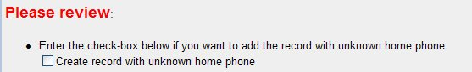
Fig 1b

Next Action:

Once the user completes all necessary fields in Add-a-Nurse Dialogue, they should choose a Next Action (see below)

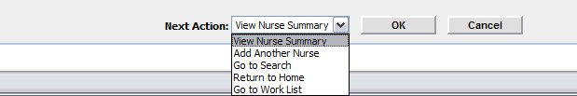
Fig 1c

View Nurse Summary: Takes user to Nurse Summary Page
Add Another Nurse: Takes user to a blank Nurse Summary Page
Go to Search: Takes user to a People Search Engine
Return to Home: Takes user to their Home Page
Go to Work List: Takes user to Work List

Function:

User Clicks [OK] →Application suggests 3 Person Ids→Application should add an [OK] [Cancel] Button next to suggestions→User chooses Person Id→Clicks [OK]→ Application adds Person and performs Next Action.

